

YEAR: 8
SUBJECT: SCIENCE

TEST: Physical and chemical change
TIME: 40 mins
QUESTIONS: Part A: Multiple Choice Questions (10 marks)
Part B: Short Answer Questions (26 marks)

TOTAL MARKS: 36marks

DO NOT WRITE ON OR MARK THIS PAPER
Part A: Multiple Choice Questions (1mark each)
Answer this section on the separate multiple – choice answer sheet

1. Which of the following is a chemical change?

- Sawdust is produced from wood being cut by a power saw.
- Water freezes to form ice.
- Fireworks explode in a colourful light display.
- Juice is obtained from an orange.
2. A permanent colour change may be an indication that a chemical reaction has taken
place. Identify which of the following is not an indication of a chemical reaction.

- sugar caramelising
- toast bread
- a glass breaking
- burning a match

3. The substances that you begin within a reaction is called as
- reactants.
- products.
- elements.
- compounds.

4. Which of the following would NOT be a physical change?

- freezing water to make ice cubes
- melting gold to make jewellery
- burning gasoline in a lawnmower
- boiling water for soup
5. The term corrosion means:

- coating iron with a material such as paint
- a chemical reaction where a metal reacts with oxygen
- a chemical reaction where oxygen is a product
- is coating iron with zinc metal

6. The Law of Conservation of Mass states that ‘During a chemical reaction, atoms are
neither created nor destroyed’. This law suggests that if a chemical reaction occurred
inside a closed container, the total mass of the container and its contents would:

- increase as more chemicals are produced by the reaction.
- decrease if the chemical reaction produces a gas.
- stay the same.
- increase or decrease depending on the type of chemical reaction.
7. Joe collected some snow and placed it in a beaker. During the day it melted to produce
clear water. Joe and his friends made the following comments about the process.

Joe: This is a chemical change as there is a change in colour.
Jill: The beaker is now warmer than when you collected the snow. This must be a
chemical change as energy is absorbed.
Jenny: This is a physical change as the trapped air bubbles react with the snow.
Jamal: This is a physical change as no new substances are created.
State who you believe is correct.

- Joe
- Jill
- Jenny
- Jamal

8. Analyse the word equation:
methane + oxygen → carbon dioxide + water + energy
This reaction shows that:

- oxygen is a product of this reaction.
- methane burns with a sooty flame.
- this is an exothermic reaction.
- a constant input of energy is required to keep the reaction going.

9. Identify which of the following would indicate an endothermic reaction.

- a gas is given off
- the reaction glows
- a precipitate forms
- the reaction feels cold to the touch

10. The recycling of aluminium can be considered a series of physical changes as shown
by the flow diagram below.

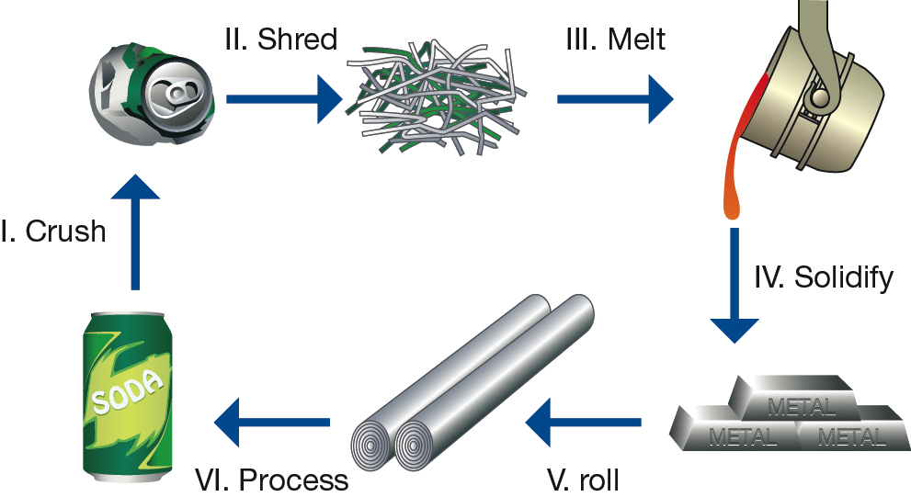

Which stages of the aluminium recycling process would be considered a change of state?

- I and II
- II and III
- III and IV
- only III

YEAR: 8
SUBJECT: SCIENCE
Name__________________________________________________
Form ____________

TEST: Physical and chemical change
TIME: 40 mins
QUESTIONS: Part A: Multiple Choice Questions (10 marks)
Part B: Short Answer Questions (26 marks)

TOTAL MARKS: 36 marks

Part A: Multiple Choice Answers (1mark each)
Put a cross (X) through the correct answer.

1 a b c d
2 a b c d
3 a b c d
4 a b c d
5 a b c d
6 a b c d
7 a b c d
8 a b c d
9 a b c d
10 a b c d

Marks

Part A: Part B:
Multiple Choice Short Answer Total

/10
/20

/32

/42

Part B: Short Answer Questions
11. Define the term precipitation. (1mark)
______________________________________________________________________________________________________________________________________________________
12. Label each process as a physical or chemical change: (6 marks)
Slicing potatoes for fries
A nail rusting
Baking cookies
Butter melting
Food spoiling
You cut your hair

13. a) Write word equations for the following chemical reactions. (2 marks)
i) Hydrogen gas and oxygen gas combine to form water.
___________________________________________________________________________
ii) Heating copper carbonate forms copper oxide and carbon dioxide.
___________________________________________________________________________
b) Write the chemical equation for the following (2 marks)
i) Hydrogen gas and oxygen gas combine to form water.
___________________________________________________________________________
ii) Heating copper carbonate forms copper oxide and carbon dioxide.
_______________________________________________________________________

14. a) Explain the difference between the terms reactants and products. (2 marks)
__________________________________________________________________________
___________________________________________________________________________
___________________________________________________________________________
___________________________________________________________________________
___________________________________________________________________________
___________________________________________________________________________

b) When magnesium metal reacts with hydrochloric acid, hydrogen gas and magnesium
chloride are formed. Identify the products and reactants of this reaction. (2 marks)

Products: _____________________________________________________________
Reactants: ____________________________________________________________

16. Complete the table below by filling in answers for parts a) to h) (8 marks)
Name | Formula
Water | a)
b) | H₂
Hydrochloric acid | c)
d) | K
Carbon dioxide | e)
f) | Cl₂
Sodium chloride | g)
h) | SO₃

17. You mix two unknown chemicals together and you expect a chemical reaction to occur. List 3 things you would look out for to know that a chemical change has occurred
(3 marks)
__________________________________________________________________________
___________________________________________________________________________
___________________________________________________________________________
___________________________________________________________________________
___________________________________________________________________________
END OF TEST

